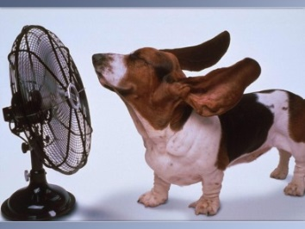
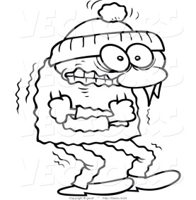
When you are Feeling Cold When you are Feeling Hot

What does the Endocrine System do? What does the Endocrine System do?

What does the Nervous System do? What does the Nervous System do?

